**Chapter 6**

**Vector Calculus**

**6.4 Green’s Theorem**

**Section Exercises**

**For the following exercises, evaluate the line integrals by applying Green’s theorem.**

147.  where *C* is the boundary of the region lying between the graphs of  and  oriented in the counterclockwise direction

Answer: 

149  where *C* is the boundary of the region lying between the graphs of  and  oriented in the counterclockwise direction

Answer: 

151.  where *C*consists of line segment *C*1from to (1, 0), followed by the semicircular arc *C*2from (1, 0) back to (1, 0)

Answer: 

**For the following exercises, use Green’s theorem.**

153. Evaluate line integral  where *C* is the boundary of

the region between circles  and  and is a positively oriented curve.

Answer: 

155. Evaluate  where *C* is the positively oriented circle of radius 2

centered at the origin.

Answer: 

157. Calculate  where *C* is a circle of radius 2 centered at the origin and oriented in the counterclockwise direction.

Answer: 

159. Evaluate integral  where *C* is the curve that follows parabola  then the line from (2, 4) to (2, 0), and finally the line from (2, 0) to (0, 0).

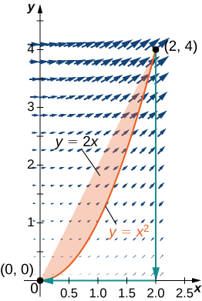

Answer: 

**For the following exercises, use Green’s theorem to find the area.**

161. Find the area between ellipse  and circle 

Answer: 

163. Find the area of the region bounded by hypocycloid  The curve is parameterized by 

Answer: 

165. Use Green’s theorem to evaluate  where is the perimeter of square  oriented counterclockwise.

Answer: 

167. Use Green’s theorem to find the area of one loop of a four-leaf rose  (*Hint*:  ).

Answer: 

169. Use Green’s theorem to find the area of the region enclosed by curve



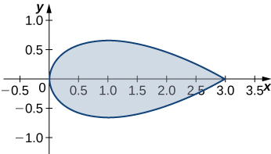

Answer: 

171. Evaluate  where *C* is the boundary of the unit square  traversed counterclockwise.

Answer: 

173. Evaluate , where *C* is any piecewise, smooth simple closed curve enclosing the origin, traversed counterclockwise.

Answer: 

**For the following exercises, use Green’s theorem to calculate the work done by force F on a particle that is moving counterclockwise around closed path *C*.**

175.  *C*: boundary of a triangle with vertices (0, 0), (5, 0), and (0, 5)

Answer: 

177. A particle starts at point  moves along the *x*-axis to (2, 0), and then travels along semicircle  to the starting point. Use Green’s theorem to find the work done on this particle by force field 

Answer: 

179. Use Green’s theorem to find the work done by force field  when an object moves once counterclockwise around ellipse 

Answer: 

181. Evaluate line integral  where *C*is the boundary of a triangle with vertices  with the counterclockwise orientation.

Answer: 

183. Use Green’s theorem to evaluate line integral  where *C*is a triangle with vertices (0, 0), (1, 0), and (1, 3) oriented clockwise.

Answer: 

185. Use Green’s theorem to evaluate line integral  where *C*is circle  oriented in the counterclockwise direction.

Answer: 

187. Let *C*be a triangular closed curve from (0, 0) to (1, 0) to (1, 1) and finally back to (0, 0). Let  Use Green’s theorem to evaluate 

Answer: 

189. Use Green’s theorem to evaluate line integral  where *C*is any smooth simple closed curve joining the origin to itself oriented in the counterclockwise direction.

Answer: 

191. Use Green’s theorem to evaluate  where *C*is a triangle with vertices (0, 0), (1, 0), and (1, 2) with positive orientation.

Answer: 

193. Let  Find the counterclockwise circulation  where *C*is a curve consisting of the line segment joining half circle  the line segment joining (1, 0) and (2, 0), and half circle 

Answer: 

195. Let *C*be the boundary of square  traversed counterclockwise. Use Green’s theorem to find 

Answer: 

197. Use Green’s Theorem to evaluate integral  where  and *C*is a unit circle oriented in the counterclockwise direction.

Answer: 

199. Calculate the outward flux of  over a square with corners  where the unit normal is outward pointing and oriented in the counterclockwise direction.

Answer: 

201. Find the flux of field  across  oriented in the counterclockwise direction.

Answer: 

203. **[T]** Let *C* be unit circle  traversed once counterclockwise. Evaluate  by using a computer algebra system.

Answer: 

205. Consider region *R* bounded by parabolas  Let *C* be the boundary of *R* oriented counterclockwise. Use Green’s theorem to evaluate 

Answer: 

**Student Project**

**Measuring Area from a Boundary: The Planimeter**

1. Explain why the total distance through which the wheel rolls the small motion just described is 

Answer: This is a proof; therefore, no answer is provided.

3. Use step 2 to show that the total rolling distance of the wheel as the tracer traverses curve *C* is

Answer: This is a proof; therefore, no answer is provided.

**Total wheel roll **

**Now that you have an equation for the total rolling distance of the wheel, connect this equation to Green’s theorem to calculate area *D* enclosed by *C*.**

5. Assume the orientation of the planimeter is as shown in [link]Figure_16_04_SP3[/link]. Explain why  and use this inequality to show there is a unique value of *Y* for each point  

Answer: This is a proof; therefore, no answer is provided.

7. Use Green’s theorem to show that 

Answer: This is a proof; therefore, no answer is provided.

**It took a bit of work, but this equation says that the variable of integration *Y* in step 3 can be replaced with *y*.**

9. Use Green’s theorem to show that the area of *D* is  The logic is similar to the logic used to show that the area of 

Answer: This is a proof; therefore, no answer is provided.

This file is copyright 2016, Rice University. All Rights Reserved.